|  |  |
| --- | --- |
| **NAME** | G.KAVIYA |
| **DEPARTMENT** | BIOMEDICAL ENGINEERING |
| **COLLEGE** | DHANALAKSHMI SRINIVASAN INSTITUTE OF TECHNOLOGY |
| **NAAN MUDHALVAN COURSE** | DIGITAL MARKETING |
| **NAAN MUDHALVAN ID** | 1904C349F7F1A08A46049E3047754FF8 |

**ASSIGNMENT QUESTION ON DIGITAL MARKETING**

1.Create a blog or website using blogspot and woedpress. Customize the theme design and post new article with 500 words.

Blogspot

<https://flowsbloom.blogspot.com/2023/08/flowers-land.html>

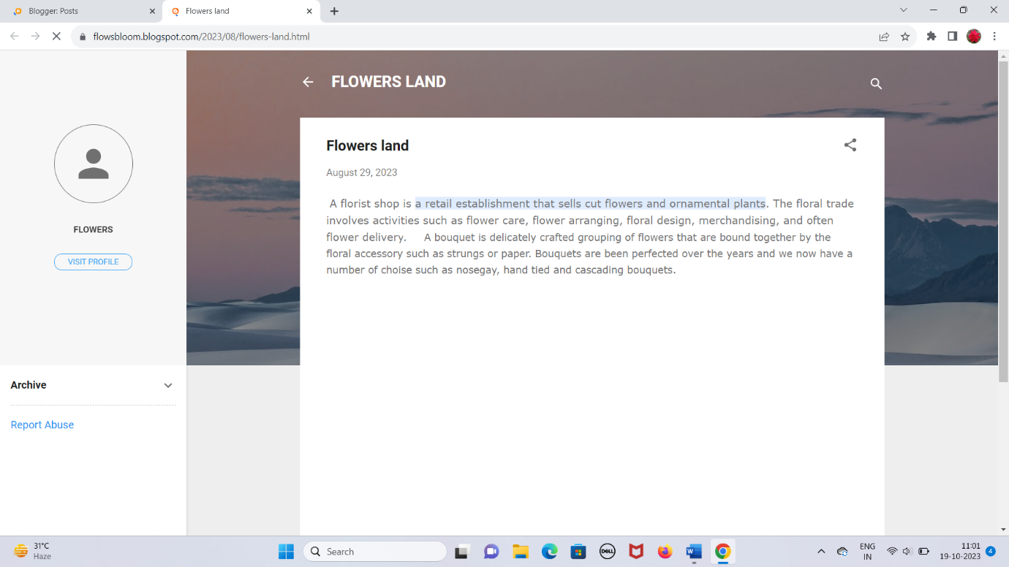

Wordpress

<https://wordpress.com/home/flowerssland.wordpress.com>

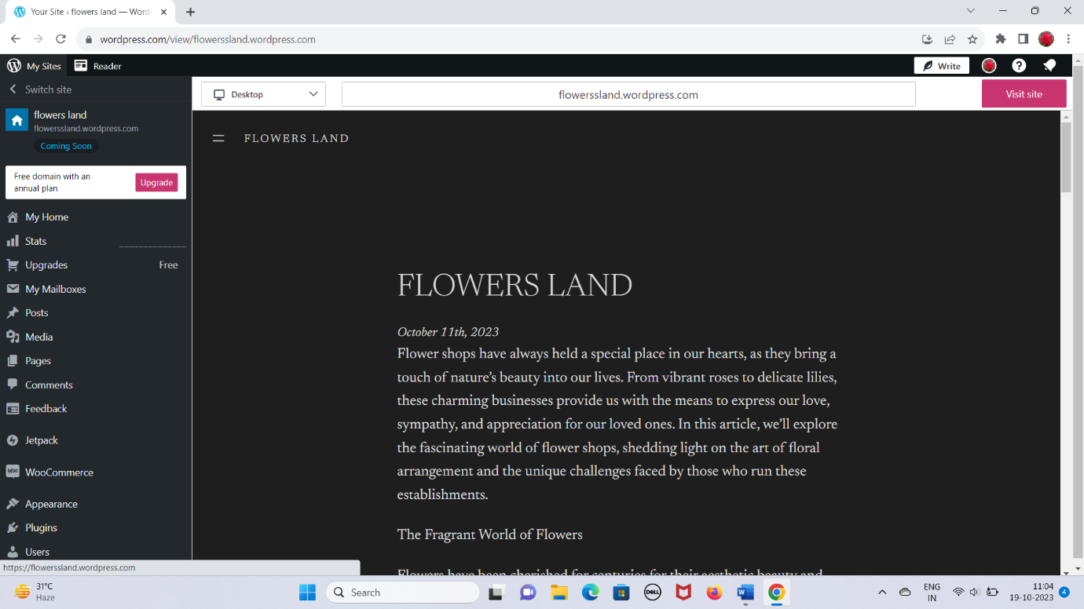

2.Create a New Facebook Business Page and post one social media poster for your brand.

<https://www.facebook.com/flowerssland>

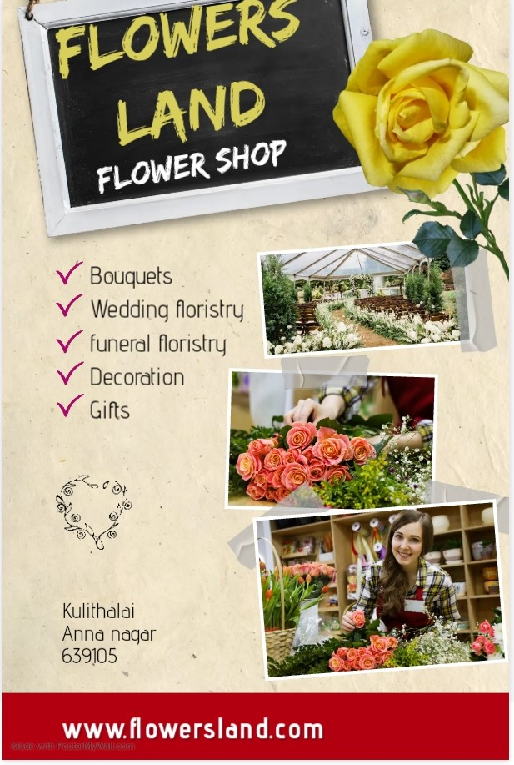

3.Create and design a social media advertisement poster using canva.

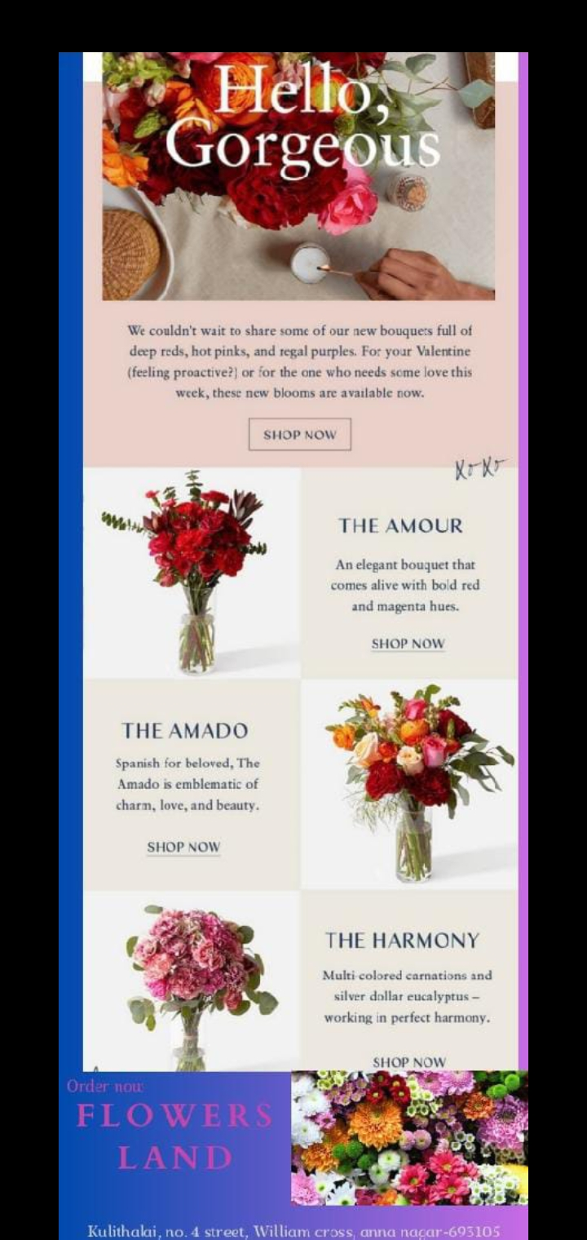

4.Create email newsletter design using Mailchimp or canva tool.

